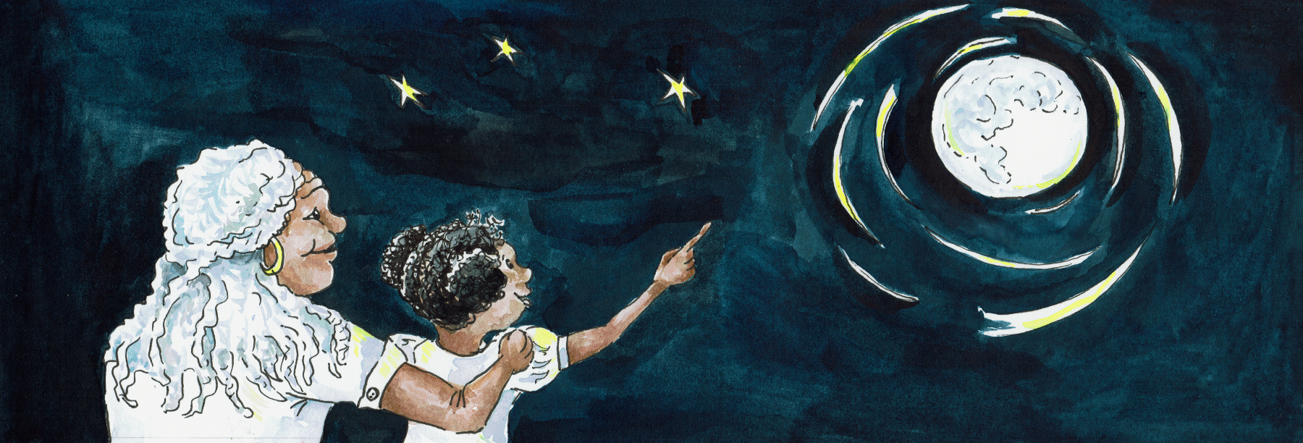
Who Are these Films For?

These films are for everyone!
We wanted to create something that everyone to enjoy together.
That could be seen and heard and signed and joined in with - or not.

I worked with David Ellington, a Deaf Filmmaker, from VS1 Productions, to make both these films.

Travelling to Moon - is signed by Alison Wherry-Alimo.
Shooting Down the Sun - is signed by David Ellington.

Shooting Down the Sun was originally made for The Vanishing Sun web resource and funded by Lunar Planetary Institute USA, with an American signer, Louise Stern.
We are very grateful for LPI’s permission to re-do in British Sign Language (BSL).

The American Sign Language version can be seen here:
http://www.lpi.usra.edu/education/explore/eclipse/

Suggested Age Range

Travelling to the Moon is ideal for 3 - 7 years and those new to learning English or BSL
Shooting Down the Sun is ideal for 7 - 12 years and confident learners in English or BSL

But they have been enjoyed by audiences of all ages around the globe.

I hope you have as much fun watching them, as I did making them!
With many, many thanks to all at VS1 Productions, http://vs1.org/

Cassandra Wye
May 2019

